Regulations:
A18

H.T No

Sreenidhi Institute of Science and Technology
(An Autonomous Institution)
Code No: 7BC02 Date: 27-June-2019 (AN)

B.Tech I-Year I-Semester External Examination, June-2019 (Supplementary)
ENGINEERING GRAPHICS AND DESIGN (EEE, ME and ECE)

Time: 3 Hours Max.Marks:70

Note: a) No additional answer sheets will be provided.
b) All sub-parts of a question must be answered at one place only, otherwise it will not be valued.
c) Missing data can be assumed suitably.

Part - A Max.Marks:20

Answer all QUESTIONS.

1. | Define representative fraction. | [2M]
2. | Define first angle projection. | [2M]
3. | What is difference between prism and pyramid? | [2M]
4. | Explain different methods of development of surfaces. | [2M]
5. | Differentiate between isometric and oblique projections. | [2M]
6. | Explain about trim, chamfer and fillet. | [2M]
7. | Construct a hexagon of side 30 mm. | [2M]
8. | Draw the projections of a square plane of side 30 mm resting on H.P on one its corner. | [2M]
9. | Define frustum of a cone. | [2M]
10. | Differentiate between copy and move. | [2M]
Part – B Max.Marks:50
ANSWER ANY FIVE QUESTIONS. EACH QUESTION CARRIES 10 MARKS.

11. |  | Construct a parabola, with the distance of the focus from the directrix as 50 mm. Also draw normal and tangent to the curve at a point 25 mm from the axis. | [10M]
12. |  | A regular pentagon of 30 mm sides is resting on VP on one of its sides. Its surface is inclined at 45⁰ to VP. Draw its projections when the side in VP makes 30⁰ with HP. | [10M]
13. |  | A hexagonal pyramid, base 25 mm side and axis 60 mm long has one of its slant edges on H.P such that two of its triangular faces containing the slant edge on which it rests are equally inclined to H.P. The top view of the axis appears to be inclined at 45⁰ to V.P. Draw its projections when its base is nearer to the observer than its apex. | [10M]
14. |  | A triangular prism with a base side of 45 mm and height 60 mm rests on its base on H.P with a rectangular face perpendicular to V.P. It is cut by an auxiliary inclined plane such that the true shape of the section is an isosceles triangle of maximum size. | [10M]
15. |  | Draw the orthographic views of below figure.  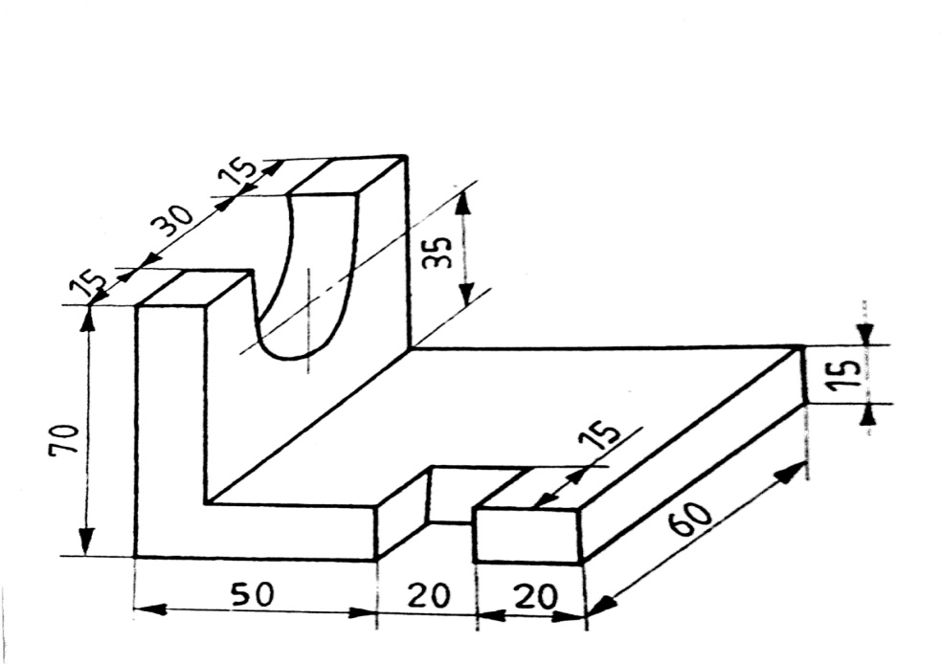 | [10M]
16. | a) | Define CAD. Explain its advantages and applications. | [5M]
 | b) | What are the various software's used in CAD. | [5M]
17. | a) | Draw the projection of points given below on a common reference line with distance between the projectors as 20mm.  i). Point A is 10 mm above HP and 25 mm in front VP  ii). Point B is 10 mm above HP and on the VP.  iii). Point C is 25 mm below HP and 20 mm behind VP  iv). Point D is 20 mm below HP and 20 mm in front of VP  v). Point E is 15 mm above HP and 25 mm behind VP | [5M]
 | b) | A 100 mm long line AB is parallel to and 20 mm in front of VP. End A is 15 mm above HP while end B is 55 mm above HP. Draw the projections of the line and inclination of the line with HP. | [5M]
18. |  | A cylinder of diameter of base diameter is 50mm and axis 70mm long, is resting on its base on H.P .It is cut by a section plane, perpendicular to V.P and inclined at 45° to H.P .The section plane is passing through the top end of an extreme generator of the cylinder .Draw the development of the lateral surface of the cut cylinder. | [10M]

-- 00 -- 00 –

